Tamarra Lewis Johnson
PR Specialist
I Am Talented Management LLC.
415 Armour Dr.
Suite 9303
Atlanta, Georgia 30324
Tamarrapr@Iamtalentedmanagement.com
Twitter @tamarrapr
Cell (404)754-9479
FOR IMMEDIATE RELEASE

Terrence L. Davidson A.K.A. “The Wig Master” 4th Annual Tranz4merz Hair Battle hosted by ONE Styling Tools

Newark, New Jersey: Mr. Terrence L. Davidson A.K.A. “The Wig Master” A.K.A. Nicki Minaj’s exclusive Hair Stylist rolled out the red carpet at a gala affair at the 4th annual Tranz4merz Hair Battle. Terrence holds this annual “Give back event” which allows up and coming hair stylists from across the country to compete for bragging rights and a cash grand prize anywhere from 5k-10k each year. Terrence Davidson has been in the industry for over 20 years but has gained his more acclaimed notoriety for creating the looks and images that you have seen on Ms. Nicki Minaj. This year “The Wig Master” brought out Reality TV artists Ms. Tionna Smalls and the former Atlanta’s V103 Radio host “Miss Sophia” to host the event while he wasted no time to grace the judges panel with the likes of the legendary hair stylist Oscar James, Reality TV star Bethany “Queen B” Bell from Hair Battle Spectacular II and the incomparable celebrity hair stylist and entrepreneur Ms. Tippi Shorter; which only names a few.
As always, Terrence opened the event with a one of a kind performance; this year land marking the most historic and iconic hairstyles of the great Ms. Nicki Minaj. After his jaw dropping performance, he let the competition begin. Terrence’s Tranz4merz Hair Battle brought the house to tears when the former FHI executives; now ONE Styling Tools executives Joseph and David Kim came on stage and presented Terrence with the very 1st styling tool under the newly endorsed tool line By Terrence L. Davidson under ONE Styling tools. Tonight’s event just marked a small piece of the pie of what the future Tranz4merz Hair Battles are yet to hold; with sponsors like ONE Styling Tools, Mizani, Organic Root Stimulator, Echelon, and Cuticle Remy XQ each event will get bigger and better than the last. Congratulations again to Shannon, the grand prize winner, for bringing the “The Zodiac” themed performance and taking home the title. And special thanks to Terrence L. Davidson for organizing and event that gives back to the community and giving away a $500.00 scholarship to Tyrell C., an Empire Beauty School student, who is at the top of his class in Newark, N.J.

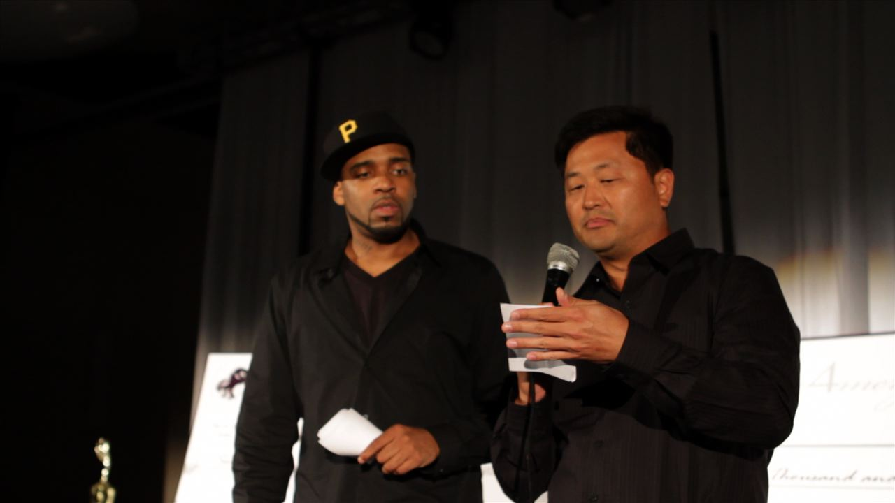
Above: David Kim from ONE Styling Tools and Terrence Davidson presenting the grand prize winner
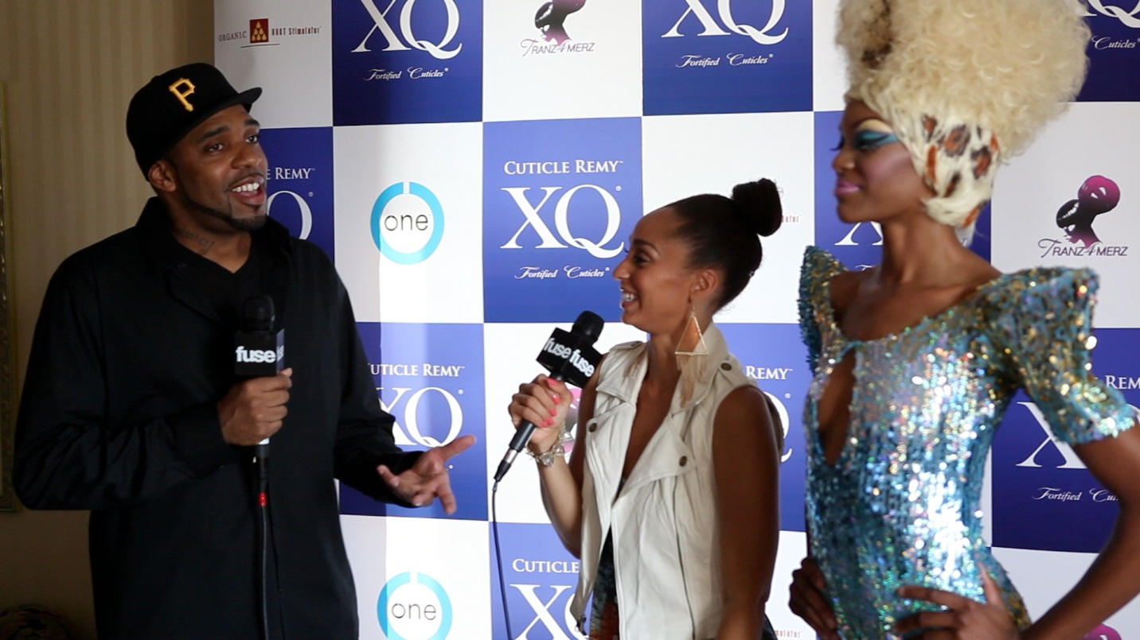
Above: Terrence Davidson on the red carpet with FUSE TV
Above: Terrence opening performance at the 4Th annual Tranz4merz Hair Battle

